Project Report

On

**Two Port Networks & Its Applications**

*submitted towards the partial fulfilment of*

*the requirement for the award of the degree of*

**Bachelor of Technology**

In

**Electrical Engineering**

Submitted by

**Ritul**

**2K20/EE/221**

Under the Supervision

of

**Prof. Kuldeep Singh**

Department of Electrical Engineering

Delhi Technological University

Bawana Road, Delhi -110042

**INTRODUCTION**

A two port network is an electrical network model with one pair of input terminals and one pair of output terminals. It is commonly used to model the voltage and current characteristics of complex electrical networks. When an electrical signal is applied across the input ports, there would be an electrical signal across output ports. The relation between input and output signals of the network can be determined by transferring various network parameters, such as, impedance, admittance, voltage ratio and current ratio.

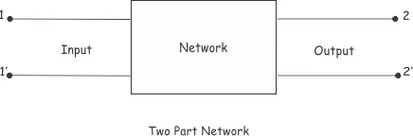

In two-port mathematical models, the network is described by a 2 by 2 square matrix of complex numbers and they establish relations between the variables given below-

* V1, voltage across port 1.
* I1, current into port 1.
* V2, voltage across port 2.
* I2, current into port 2.

The transfer voltage ratio function is,



The transfer current ratio function is,



The transfer impedance function is,



The transfer admittance function is,



**Z Parameters**

Z parameters are also known as impedance parameters. In Z parameter for analysing two port networks, the voltages are represented as the function of currents. They are also known as open-circuit impedance parameters as they are calculated under open circuit conditions. The Z parameters are,

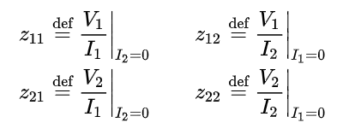

The voltages are represented as-

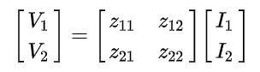

**Y Parameters**

Y parameter of two port network is an admittance matrix. Since admittance is the ratio of circuit current and voltage, therefore this admittance matrix gives the relationship between the input and output current and voltage of the network. It is also known as short circuit admittance parameter.

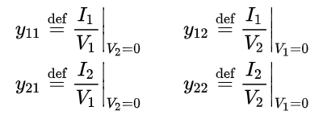

In the two port network represented by admittance, the current and voltage related by the following equations,

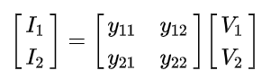

**H Parameter**

H parameters are also known as hybrid parameters. In hybrid parameter circuit, voltage gain, current gain, impedance and admittance are used to determines relation between current and voltage of two port network.

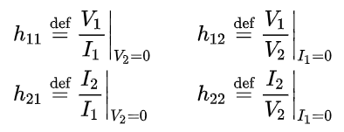

Hence,

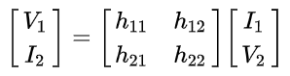

**ABCD Parameter**

The ABCD-parameters are known variously as chain, cascade, or transmission line parameters.

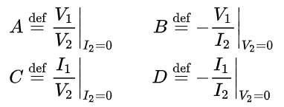

In matrix form it can be written as,

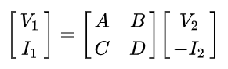

**TWO-PORT NETWORK ANALYSIS FOR WIRELESS POWER TRANSFER (WPT) SYSTEMS**

**DEFINITION**

Wireless power transfer (WPT) or electromagnetic power transfer is the transmission of electrical energy without wires as a physical link. In a wireless power transmission system, a transmitter device, driven by electric power from a power source, generates a time-varying electromagnetic field, which transmits power across space to a receiver device, which extracts power from the field and supplies it to an electrical load.

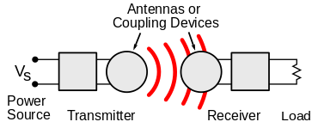

A typical WPT system includes a transmitter (Tx) connected to a power source through a primary compensation network, and a receiver (Rx) connected to the load through a secondary compensation network. Optionally, there can be multiple coils in-between Tx and Rx as repeaters. These compensation networks can also be termed as impedance matching networks or load transformation networks in the literature. Regardless of the complexity of the WPT system, any single-Tx – single-Rx WPT system can be represented as a two-port network.

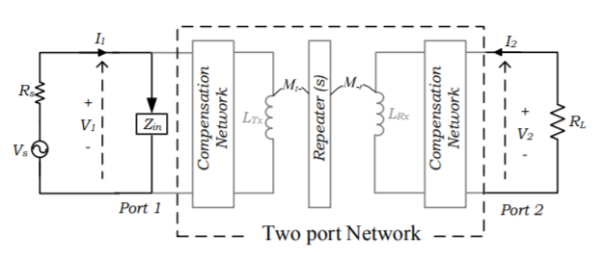

The two-port network can be modelled using the impedance parameter matrix where Z11, Z12, Z21, and Z22 are impedance parameters, V1 and V2 are voltages at port 1 and port 2, respectively, and I1 and I2 are currents flowing into port 1 and port 2, respectively.

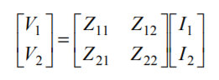

If all the parameters of the WPT system are known, then the impedance matrix can be calculated. Once the impedance matrix and the load characteristics are known, the performance of the WPT system can be fully characterized. First, the input impedance, Zin, seen at port 1, can be determined using,

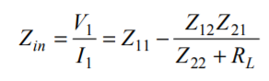

Afterwards, the input power (Pin) flowing into the two-port network, and the output power (Pout) received at the load are calculated.

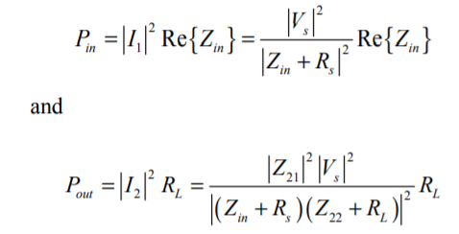

However, the powers Pin, and Pout are dependent on the source voltage, therefore, they cannot be considered as normalized terms for a generalized comparison. Therefore, a number of gain parameters have been defined to represent normalized performance indices.

**PERFORMANCE INDICES**

Three gain parameters are typically used in microwave engineering: power gain (GP), available gain (GA) and transducer gain (GT) as-

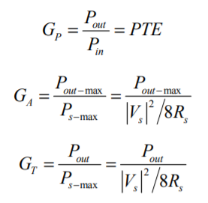

Here, GP represents power transfer efficiency (PTE) of the WPT systems, therefore, it is a very useful term for the characterization of WPT systems. Gain terms, GA and GT represent the maximum available output power (Pout-max) and output power (Pout) at a given operating point normalized to the maximum available input power at the source (Ps-max), respectively. If the source impedance is negligibly small (i.e., a nearly ideal voltage source), square voltage gain represents the ratio between the output power of the WPT system and the output power when the load is directly connected to the source. Therefore, it compares the power capability of the WPT system with the direct wired connection with the source. Therefore, the source impedance is neglected for the subsequent analysis.



**OPTIMIZATION OF WPT SYSTEMS**

In order to analyse the performance characteristics with respect to the impedance parameters, the equivalent impedance parameters are written as where rij and xij are the real and imaginary parts, respectively.

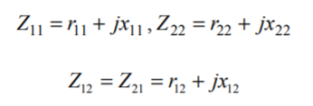

Here, the off-diagonal terms are identical (Z12=Z21) because the network is reciprocal. The optimum value of x22 which gives maximum PTE, is computed by equating the derivative to zero, as

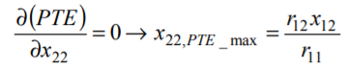

and the respective maximum PTE is found using

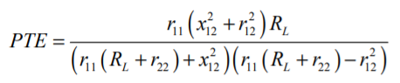

For a classical 2-coil WPT, x22 represents the reactive impedance of the Rx coil. According to (11), for the classical 2- coil WPT, x22,PTE_max  is zero, since the value of r12 is zero which coincides with the well-known relation of maximum PTE at the resonance frequency of Rx. Since, x11 determines the reactive component of the input impedance. Therefore, the value of x11 can be chosen to make Zin purely real,

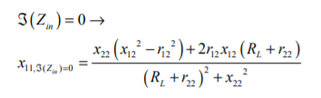

With the optimal values of x11 and x22, GV2 reduces to-

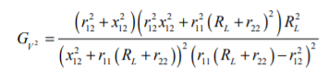

The optimal load which gives maximum efficiency can be derived as-

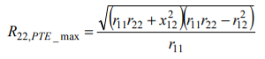

If the load is assumed to be at its optimal value, the maximum efficiency (PTEmax) can be derived as-

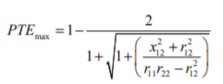

It can be seen that higher r12 is always better to obtain higher efficiency. The upper limit for r12 is (r11*r22)1/2.

It is observed from the above equations that GV2 is monotonically increasing with the increase of load resistance. Therefore, in terms of high GV2, higher load resistance is always better. However, in practice, it is not required to maximize the voltage ratio. Instead, it is only required to keep the voltage ratio at a realistic value close to unity. One cannot maximize both PTE and the voltage ratio at the same time. The maximum efficiency condition may result in a lower voltage ratio. Therefore, a balance between PTE and GV2 should be considered.

**SIMULATION**

**Z Parameter**

**I/P is Open circuit**

Zeq=((1k+1k) || 1k) + 470=1.1367 kohm

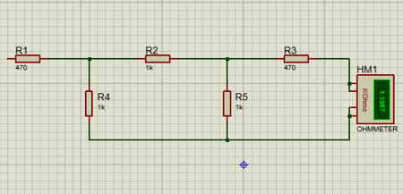

Let node at R5 be N1 & at R4 be N2, Then-

5/470=N1/1k+(N1-N2)/1k

(N2-N1)/1k+N2/1k+N2/470=0

Therefore, N2=1.47 V

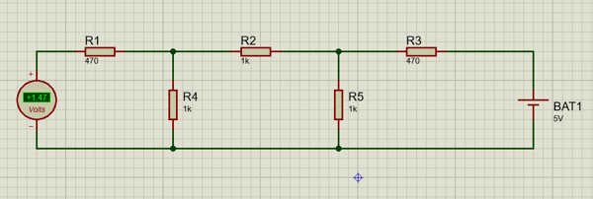

V2=I2.Z

5=I2.(1136.7)

I2=4.40 mA

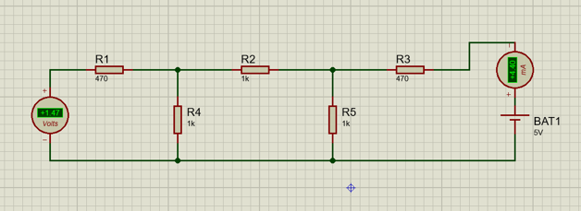

**O/P is Open circuit**

Zeq=((1k+1k) || 1k) + 470=1.1367 kohm

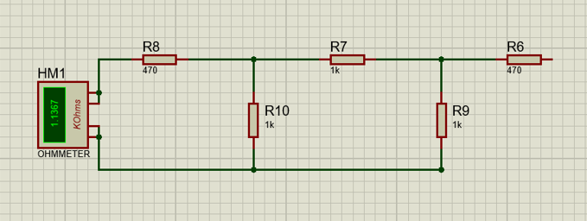

Let node at R9 be N1, node at R10 be N2

5/470=N2/1k+(N2-N1)/1k

(N1-N2)/1k+N1/1k+N1/470=0

Therefore, N1=1.47 V

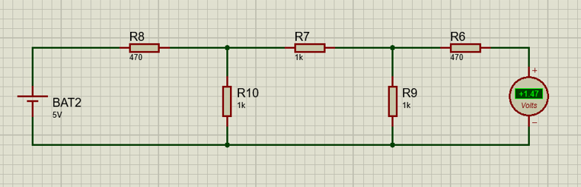

V1=I1.Z

5=I1.(1136.7)

I1=4.40 mA

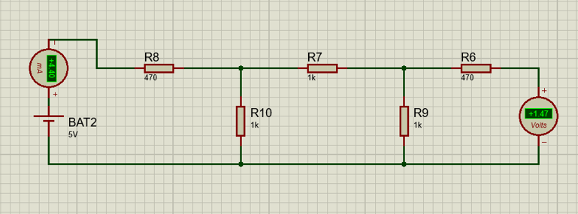

|  |  |  |  |  |  |
| --- | --- | --- | --- | --- | --- |
| I/P Open Circuit | | | O/P Open Circuit | | |
| V2 | V1 | I2 | V2 | V1 | I1 |
| 5 V | 1.47 V | 4.40 mA | 1.47 V | 5 V | 4.40 mA |

|  |  |  |  |
| --- | --- | --- | --- |
| Z11 | Z12 | Z21 | Z22 |
| 1136.7 | 334.1 | 334.1 | 1136.7 |

**Y Parameter**

**I/P is Short Circuit**

Zeq= 470 + (1k || (1k + (470 || 1k)))=1.0389 kohm

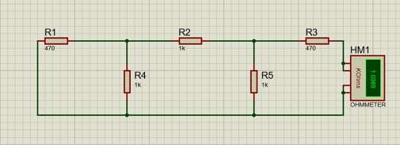

V2=5 V

Z=1.0389 kohm

I2=4.81 mA

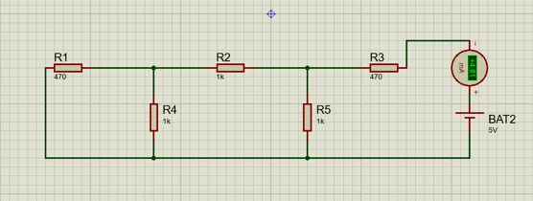

5=470N3+1k(N3-N2)

1k(N2-N3)+1k(N2)+1k(N2-N1)=0

1k(N1-N2)+470(N1)=0

N1=I1=1.41 mA N3=I2=4.81 mA

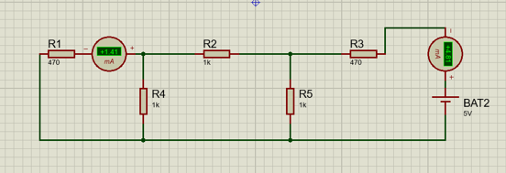

**O/P is Short Circuit**

Zeq=470 + (1k || (1k + (470 || 1k)))=1.0389 kohm

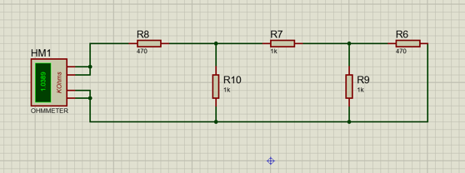

V1=5 V

Z=1.0389 kohm

I1=V1/Z=4.81 mA

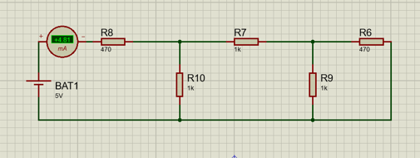

5=470N1+1k(N1-N2)

1k(N2-N1)+1k(N2)+1k(N2-N3)=0

1k(N3-N2)+470(N3)=0

N1=I1=4.81 mA N3=I2=1.41 mA

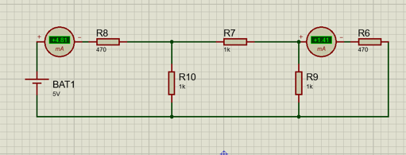

|  |  |  |  |  |  |
| --- | --- | --- | --- | --- | --- |
| I/P Short Circuit | | | O/P Short Circuit | | |
| V2 | I1 | I2 | V1 | I1 | I2 |
| 5 V | 1.41 mA | 4.81 mA | 5 V | 4.81 mA | 1.41 mA |

|  |  |  |  |
| --- | --- | --- | --- |
| Y11 | Y12 | Y21 | Y22 |
| 9.62*10^-4 | 2.82*10^-4 | 2.82*10^-4 | 9.62*10^-4 |

**H Parameter**

**I/P is Open Circuit**

Zeq=((1k+1k) || 1k) + 470=1.1367 kohm

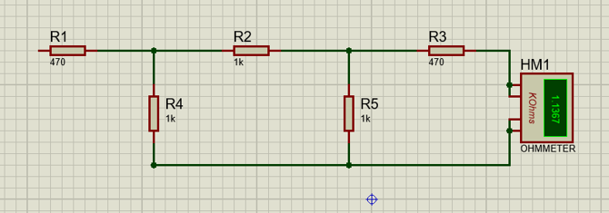

Let node at R5 be N1 & at R4 be N2, Then-

5/470=N1/1k+(N1-N2)/1k

(N2-N1)/1k+N2/1k+N2/470=0

Therefore, N2=1.47 V

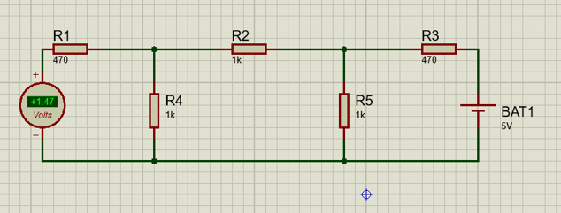

V2=I2.Z22

5=I2.(1136.7)

I2=4.40 mA

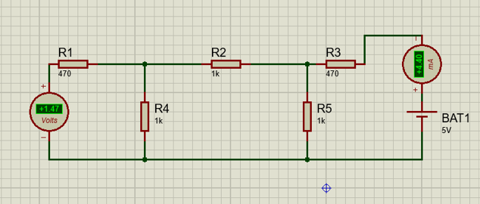

**O/P is Short Circuit**

Zeq=470 + (1k || (1k + (470 || 1k)))=1.0389 kohm

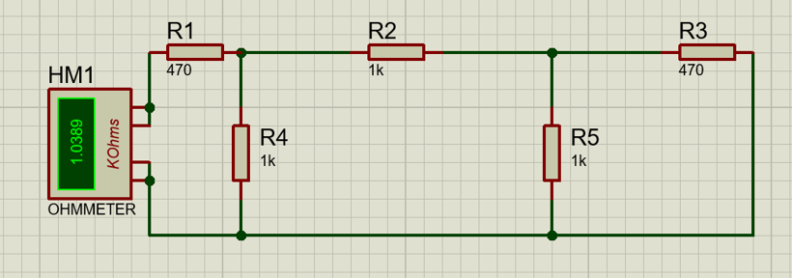

V1=5 V

Z= 1.0389

I1=V1/Z=4.81 mA

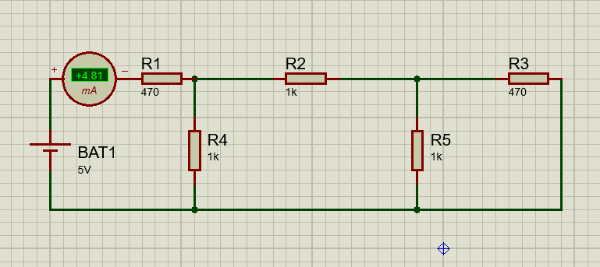

5=470N1+1k(N1-N2)

1k(N2-N1)+1k(N2)+1k(N2-N3)=0

1k(N3-N2)+470(N3)=0

N1=I1=4.81 mA N3=I2=1.41 mA

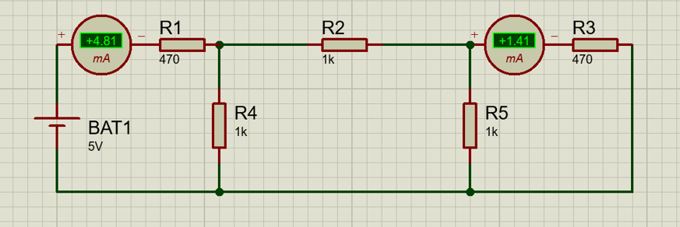

|  |  |  |  |  |  |
| --- | --- | --- | --- | --- | --- |
| I/P Open Circuit | | | O/P Short Circuit | | |
| V1 | V2 | I2 | V1 | I1 | I2 |
| 1.47 V | 5 V | 4.40 mA | 5 V | 4.81 mA | 1.41 mA |

|  |  |  |  |
| --- | --- | --- | --- |
| H11 | H12 | H21 | H22 |
| 1039.5 | 0.294 | 0.2931 | 8.8*10^-4 |

**ABCD Parameter**

**O/P is Open Circuit**

Zeq=((1k+1k) || 1k) + 470=1.1367 kohm

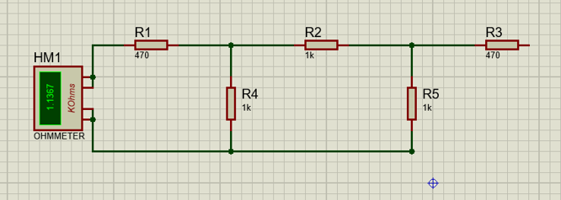

Let node at R5 be N1, node at R4 be N2

5/470=N2/1k+(N2-N1)/1k

(N1-N2)/1k+N1/1k+N1/470=0

Therefore, N1=1.47 V

V1=I1.Z

5=I1.(1136.7)

I1=4.40 mA

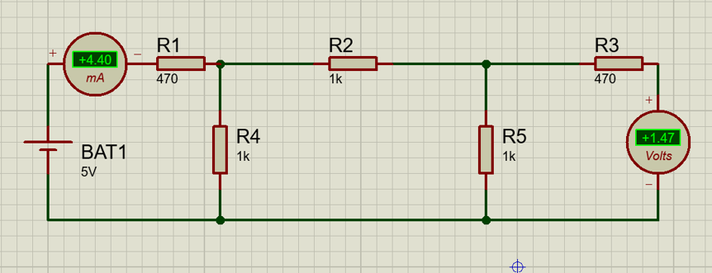

**O/P is Short Circuit**

Zeq= 470 + (1k || (1k + (470 || 1k)))=1.0389 kohm

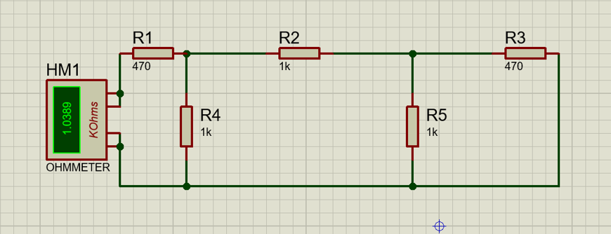

V1=5 V

Z= 1.0389

I1=V1/Z=4.81 mA

5=470N1+1k(N1-N2)

1k(N2-N1)+1k(N2)+1k(N2-N3)=0

1k(N3-N2)+470(N3)=0

N1=I1=4.81 mA N3=I2=1.41 mA

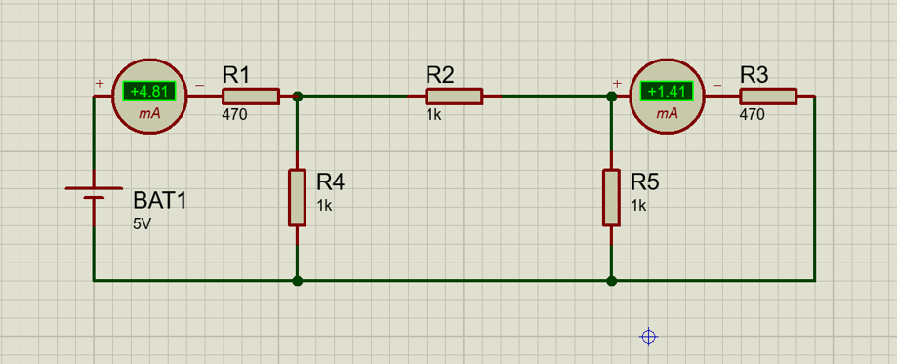

|  |  |  |  |  |  |
| --- | --- | --- | --- | --- | --- |
| O/P Open Circuit | | | O/P Short Circuit | | |
| V1 | V2 | I1 | V1 | I1 | I2 |
| 5 V | 1.47 V | 4.40 mA | 5 V | 4.81 mA | 1.41 mA |

|  |  |  |  |
| --- | --- | --- | --- |
| A | B | C | D |
| 3.401 | -3546.1 | 2.993*10^-3 | -3.411 |